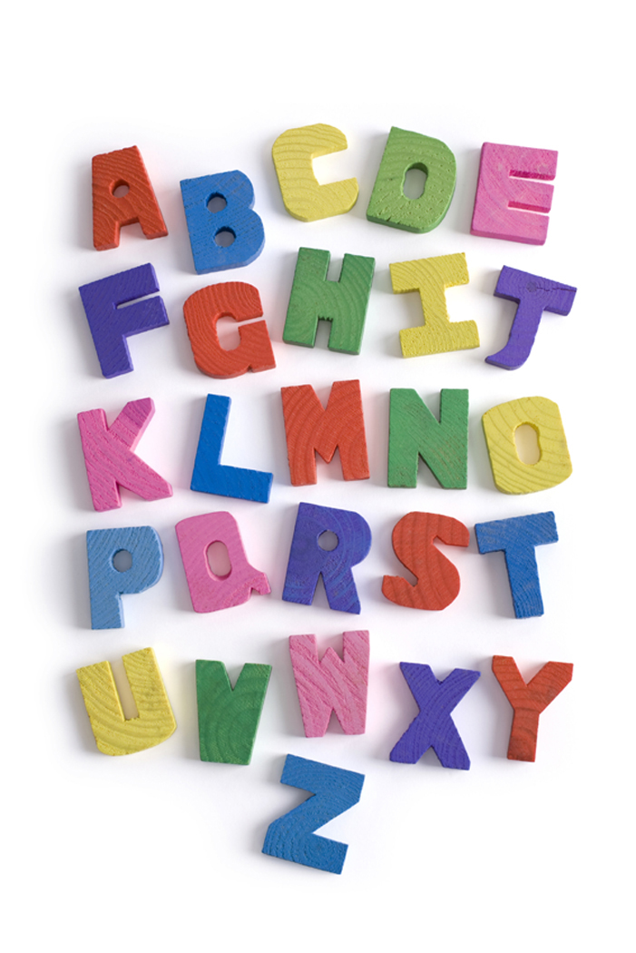
Sarah Godwin’s Newsletter
Buck Lake Elementary
September 4, 2015

Most of the children are making good adjustments to our routines. Please continue to reinforce at home the importance of listening to their teachers and the other adults here and doing their best to follow directions and rules.

Thank you for making the effort to have your child at school before the morning bell rings.

Open House is coming up on September 15 at 5:30. Children are invited and it is only an hour long. An orange flyer went home today.

I have been assessing the children’s entrance skills. This will be going on for some time as there are a number of required assessments to complete and much of it is individually administered.

Some of the language arts concepts and skills we are working on include listening for rhyming and an introduction to the alphabet and letter shapes. We are also working on retelling stories. Your child will be bringing home some little paper books. Have your child practice reading these stories to you. Also talk about the details of the story. Oral language development by sequencing a story and telling details are important skills. Your child will bring home many more of these little paper books that you will need to keep together to re-read throughout the year. I suggest using a basket for storing them. Our first sight words are I, the and can. It is important that your child keep up as the sight words are introduced.

In math, we are practicing counting objects into sets and reading and writing the numerals and the words for the numbers, 0-5. We had our first math chapter test on Friday and everyone did quite well. When the packet of math homework comes home for each chapter, you will know that the test will be coming up soon. The homework should be completed, but does not need to be returned. We are also doing daily activities when we do our calendar that build math skills through repetition. We set up our rain gauge in our little garden to measure and record the rain. We also record the temperature each morning.

SEND A LIGHT SWEATER OR JACKET WITH NAME FOR ROOM USE.

Sarah Godwin

